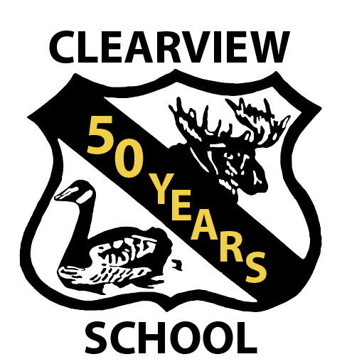
October 1969 – June 2020
358 pages of fun!!
Attention all community members, students, parents, grandparents, and great grandparents!!!!
Clearview School turned 50 years old June 2020. We have put together a historical & pictorial presentation that we hope can be enjoyed by all.
The book is in its final draft. We don’t expect many changes except maybe line spacing and the odd typo. We have tried to include everyone – but we all know this is just not always possible. It is hoped that you or your family members are represented in a photo within the book or at least on a register from the 70’s.
The printer for the book is still a work in progress – we are getting quotes from both local and non-local suppliers. They have provided us with rough estimates only as the number of books ordered always affects the overall cost of each book.
One quote is for a hard plastic covered book with a metal spiral binding on heavy gauge paper (like the paper we used to create the draft) color and black and white.

Cost per book $40.00 Shipping in Canada $20.00 Shipping to the USA $25.00

The quotes on a hard cover book have not been received to date.
If you or a family member would be interested in a copy of this book, please provide your information (name, email &/or mailing address, how many copies, hard or soft cover) to clearview@prn.bc.ca. Books are on display at the Cecil Lake Store, Goodlow Store & Bear Canyon Post Office. This will enable us to make final decisions in September so the book can be purchased for Christmas Gifts. More information will be sent out on the Clearview Web Page and on the Clearview Facebook Page.
Website: clearview@prn.bc.ca / Facebook: Clearview Elementary/Jr. Sec. School

